**Objective Questions:**

1. What is the distribution of account balances across different regions?

The chart illustrates the differences in account balance distribution among regions: Region A has a higher proportion of accounts with larger balances, Region C shows a lower concentration of such accounts, and Region B displays a more varied distribution, indicating a diverse range of account sizes

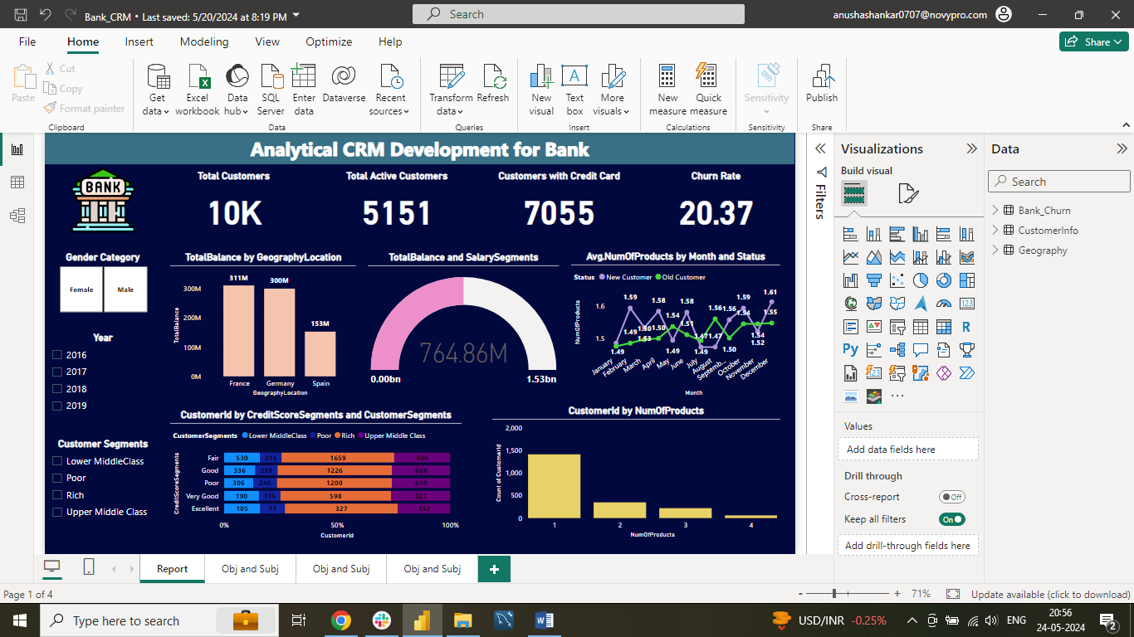

1. Identify the top 5 customers with the highest Estimated Salary in the last quarter of the year (SQL)

This SQL query selects the top 5 customers with the highest estimated salaries who joined the bank during the fourth quarter of the year

* Filters data for customers who joined in the fourth quarter (WHERE EXTRACT(QUARTER FROM BankDOJ) = 4)
* Orders the results by estimated salary in descending order (ORDER BY estimatedsalary DESC)
* Restricts the output to the top 5 customers (LIMIT 5)

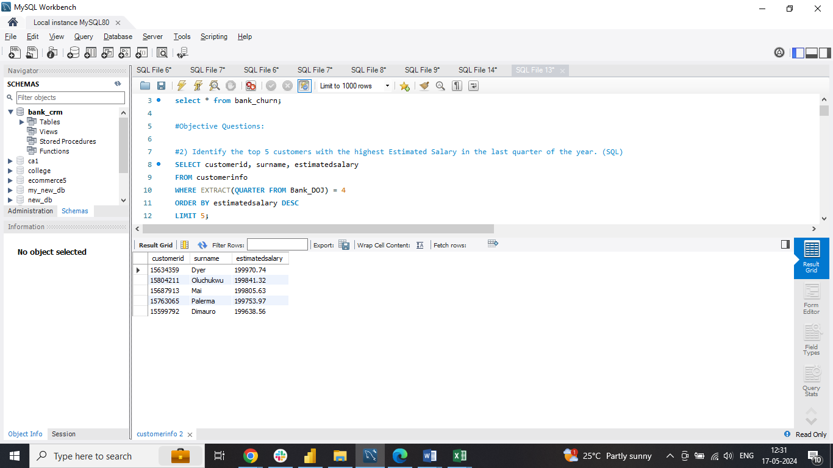

1. Calculate the average number of products used by customers who have a credit card (SQL)

* Filters data for customers who have a credit card (WHERE HasCrCard = 1)
* Computes the average number of products for these customers (AVG(NumOfProducts))
* Assigns an alias (avg_products_with_credit_card) to the computed result for clarity

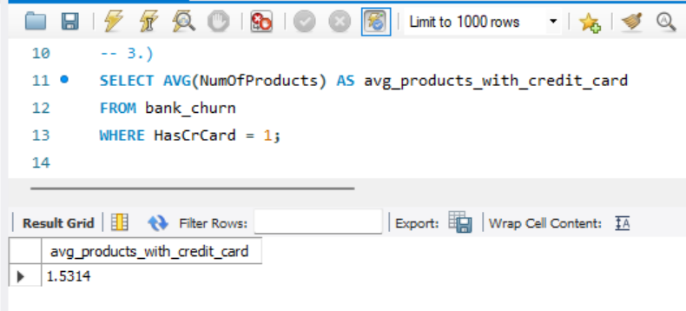

1. Determine the churn rate by gender for the most recent year in the dataset

This analysis evaluates the customer churn rate by gender (male/female) for the most recent year using a Bank DOJ slicer. A calculated measure (ChurnRate = DIVIDE([LostCustomers], [TotalCustomers]) * 100) determines the churn rate

* Use the Gender slicer to view churn rates for male or female customers within the selected year

This offers insights into potential gender disparities in churn rates. Including a chart can enhance visualization and understanding

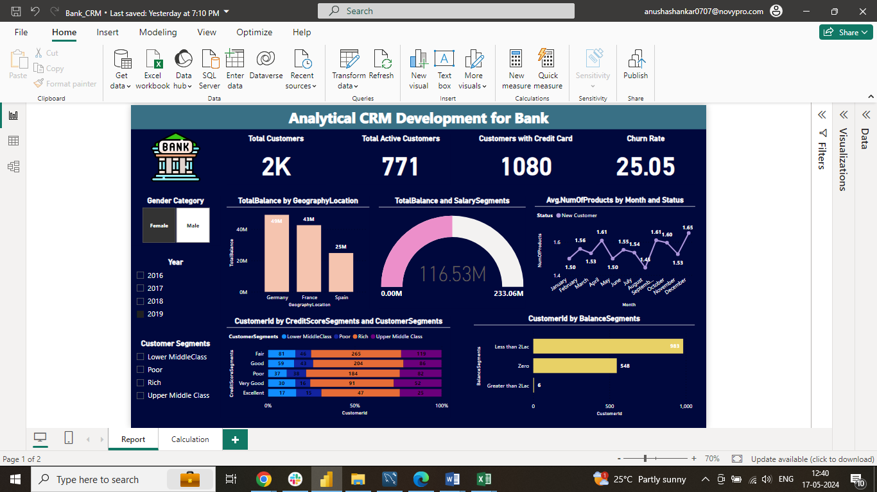 

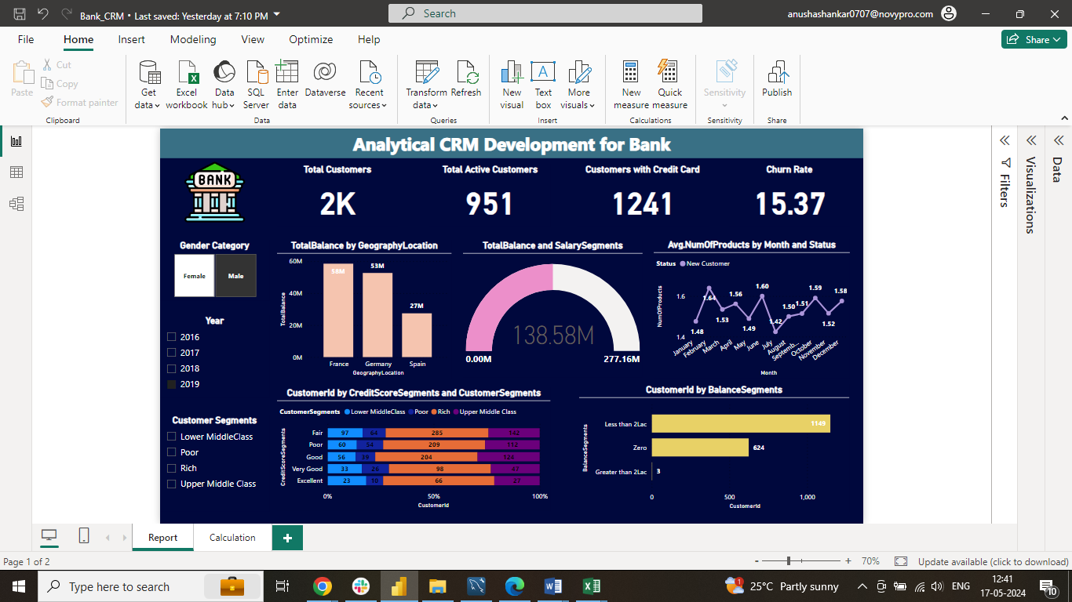 

1. Compare the average credit score of customers who have exited and those who remain (SQL)

This SQL query compares the average credit scores of customers who exited the bank (Exited = 1) to those who remained (Exited = 0).

* Groups data by customer exit status (GROUP BY Exited)
* Calculates the average credit score for each group (AVG(CreditScore))
* Assigns aliases for clarity (avg_credit_score)

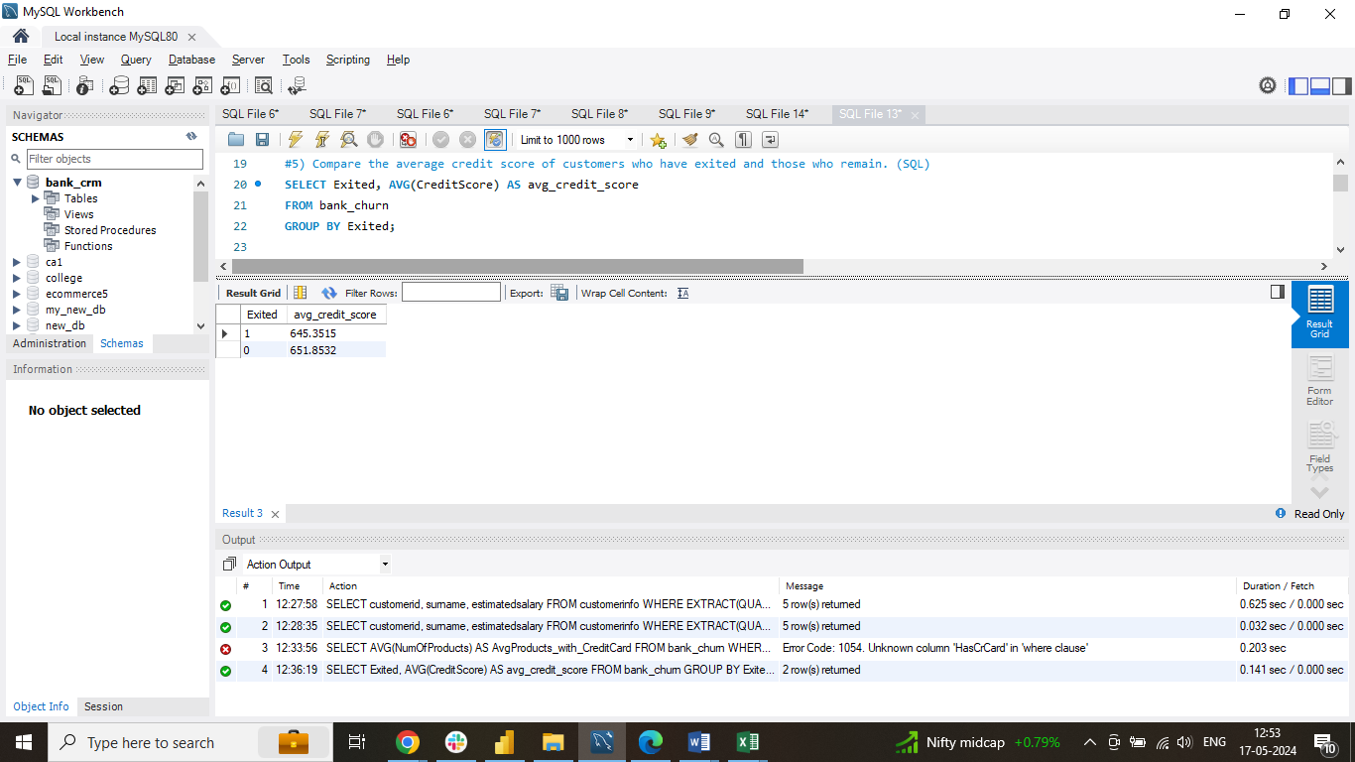

1. Which gender has a higher average estimated salary, and how does it relate to the number of active accounts? (SQL)

This query compares the average estimated salary between genders and examines its relationship with the number of active accounts

* It joins the customerinfo (c) and bank_churn (b) tables using CustomerID
* It filters for active accounts (IsActiveMember = 1) in bank_churn
* A CASE statement translates the numeric genderid to 'Male' or 'Female' for clarity
* It groups by GenderID (consider renaming to Gender for better readability) and calculates:

○ active_accounts: The count of active accounts for each gender using COUNT(b.IsActiveMember)

○ avg_salary: The average estimated salary for each gender using AVG(c.estimatedsalary)

* It orders the results by avg_salary in descending order

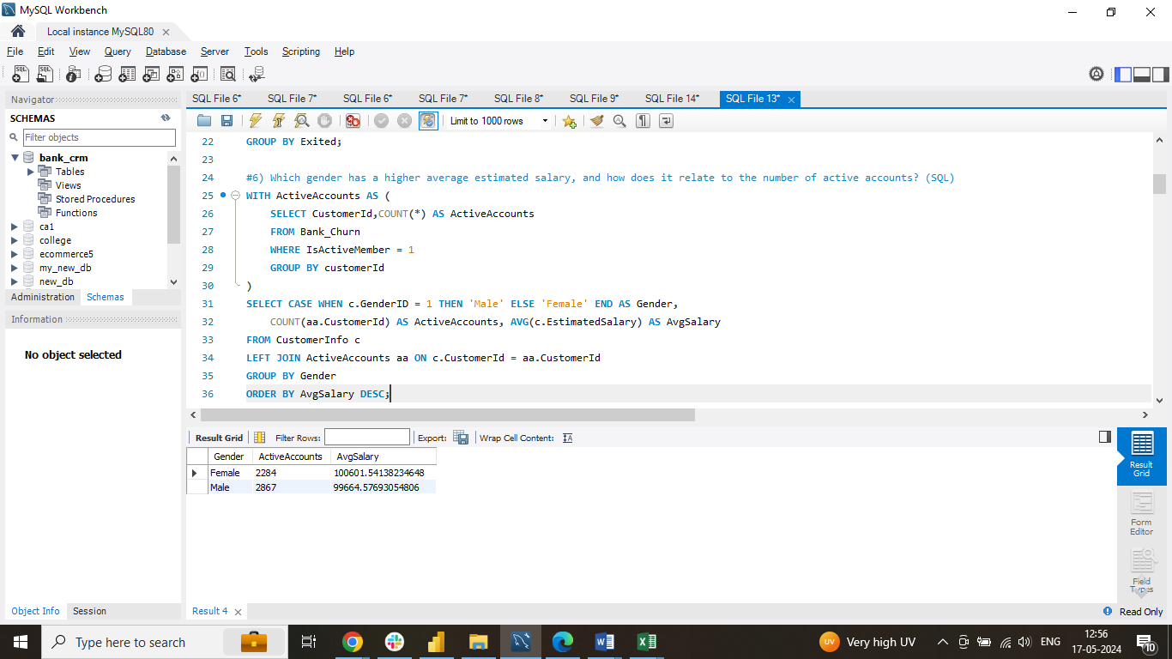

1. Segment the customers based on their credit score and identify the segment with the highest exit rate (SQL)

This query employs a Common Table Expression (CTE) named credit_score_segments to classify customers based on their credit scores

* The CTE uses a CASE statement to label segments (Excellent, Very Good, etc.) according to credit score ranges
* The main query selects the credit_score_segment and computes the average exit rate for each segment
* The exit rate is calculated using a CASE statement within the AVG function:
* 0 for inactive members (isactivemember = 0)
* 1 for active members
* The results are grouped by credit_score_segment and sorted by exit_rate in descending order
* LIMIT 1 displays the segment with the highest average exit rate

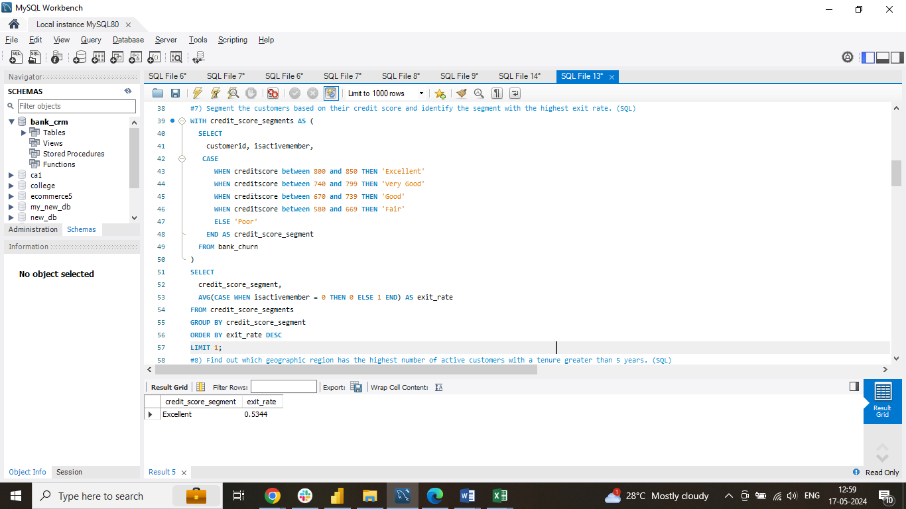

1. Find out which geographic region has the highest number of active customers with a tenure greater than 5 years (SQL)

This query retrieves the geographic region with the highest number of active customers who have maintained a tenure of more than 5 years with the bank.

* It performs a join operation across three tables:
* geography (g) for customer location data
* customerinfo (c) to associate customer IDs with geographic locations
* bank_churn (b) for customer activity and tenure information
* It filters for customers with a tenure greater than 5 years (b.tenure > 5)
* The results are grouped by geographylocation, and active customers are counted using COUNT(b.customerId)
* The query orders the results by the count of active customers in descending order and utilizes LIMIT 1 to display the region with the highest count

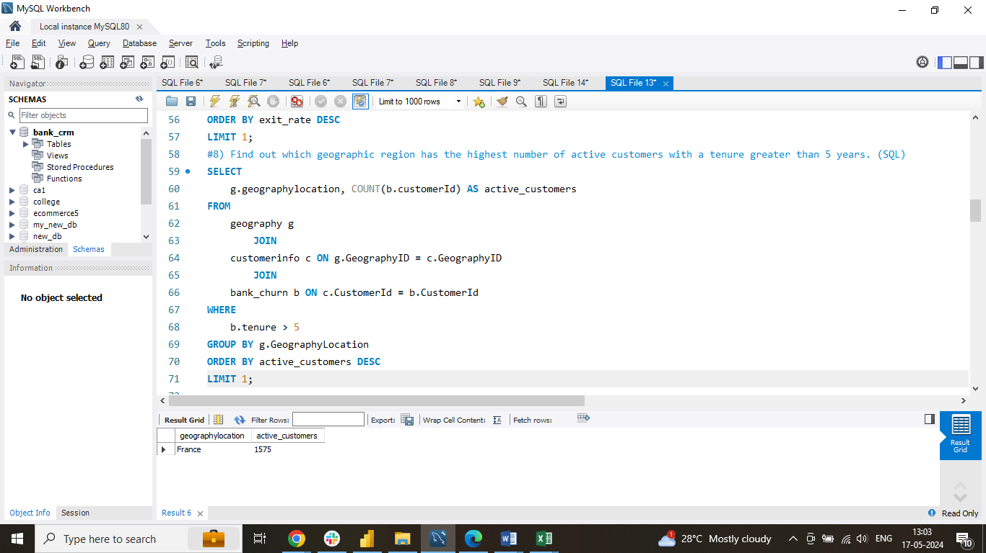

1. What is the impact of having a credit card on customer churn, based on the available data?

The chart reveals a potentially higher churn rate for customers with credit cards (HasCrCard = 1) compared to those without credit cards

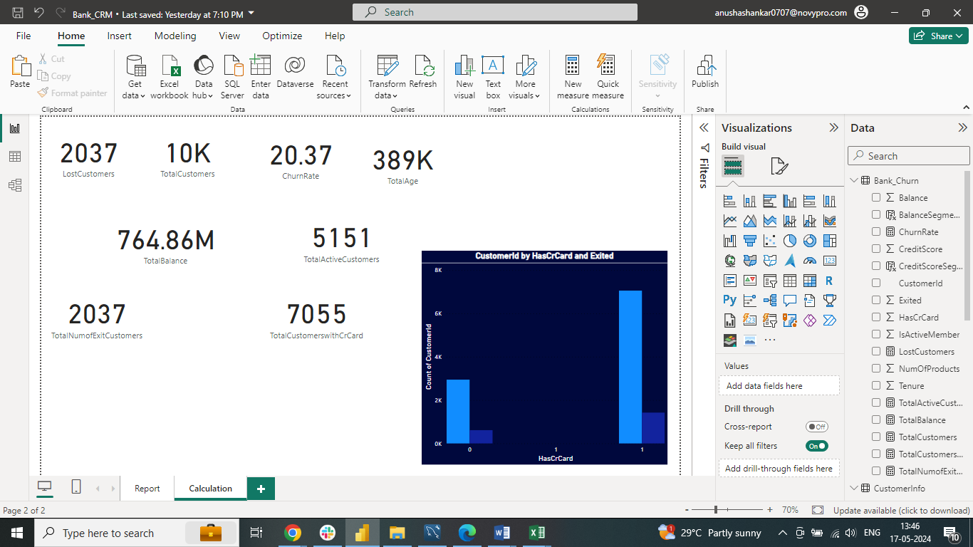

1. For customers who have exited, what is the most common number of products they have used?

According to the bar chart described, it illustrates the frequency distribution of the number of products utilized by customers who have churned (exited the bank). The horizontal x-axis indicates the number of products used, while the vertical y-axis represents the count of customers associated with each product count

Key Observations:

* The predominant usage scenario among exiting customers is with a single product
* This implies that a notable portion of churned customers had engaged with only one product

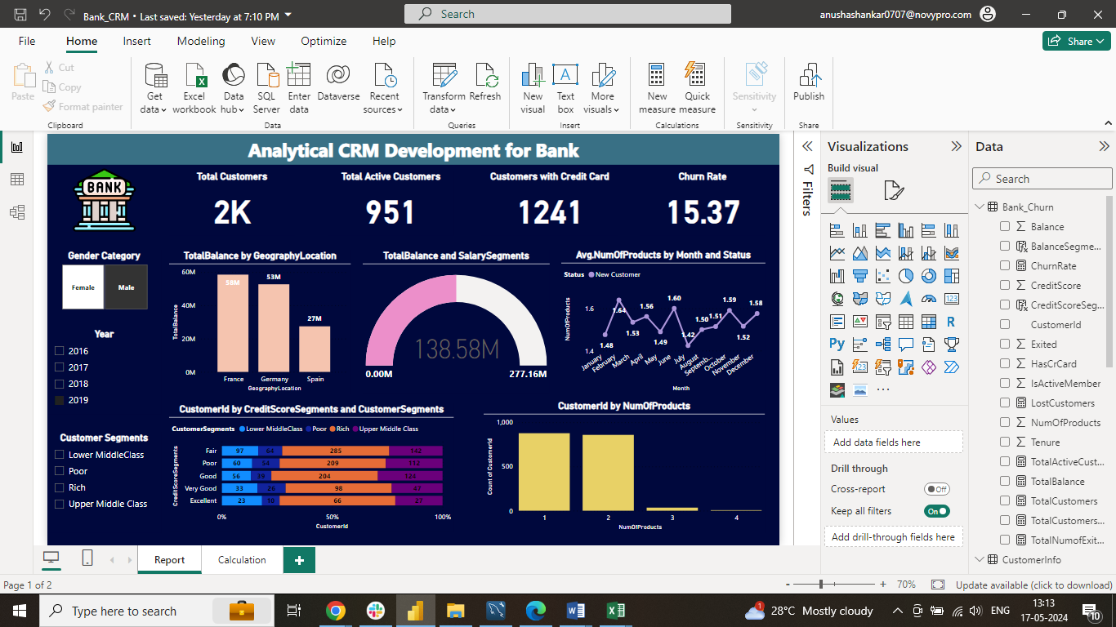

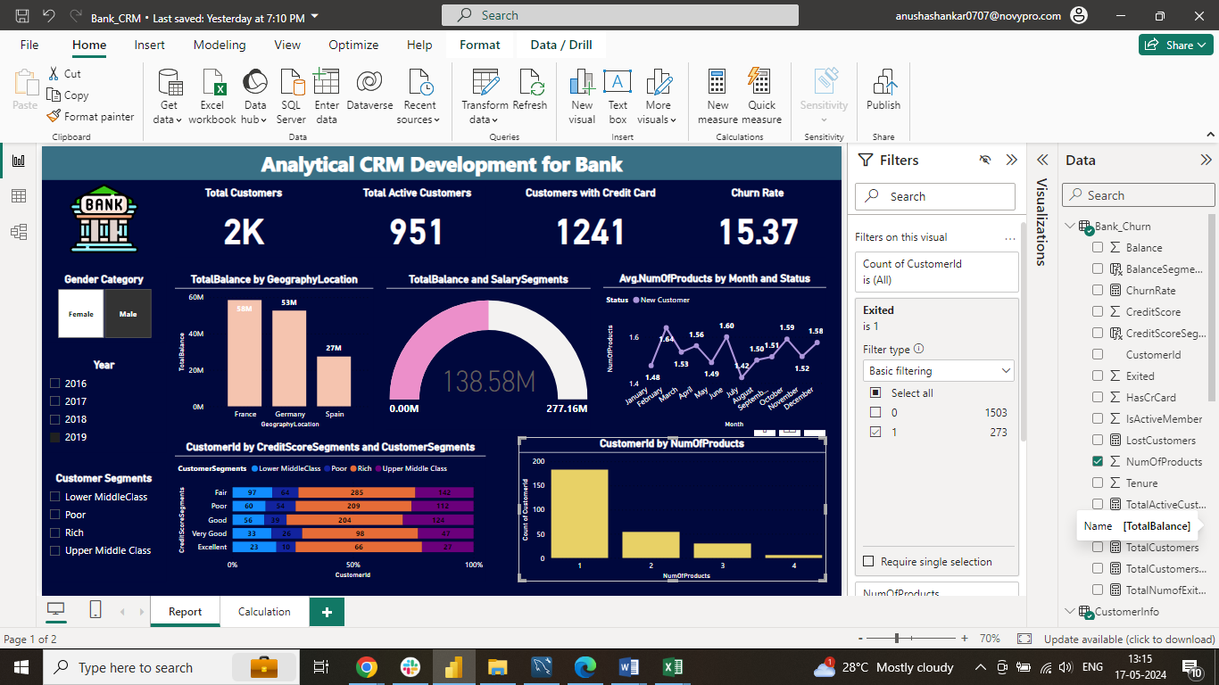

1. Examine the trend of customers joining over time and identify any seasonal patterns (yearly or monthly). Prepare the data through SQL and then visualize it

From the description provided, the chart represents a time series graph depicting the count of customers joining the bank over time, likely categorized by year and month. Here's an analysis of the key insights and a brief explanation

Key Observations:

* Trend Analysis: The graph suggests a consistent upward trend in customer acquisition over the observed period. This signifies a positive trajectory in the bank's customer base expansion
* Potential Seasonal Patterns: While there are indications of possible seasonal variations, particularly with a potential peak around December, the limited data points make it challenging to ascertain a definitive seasonal trend

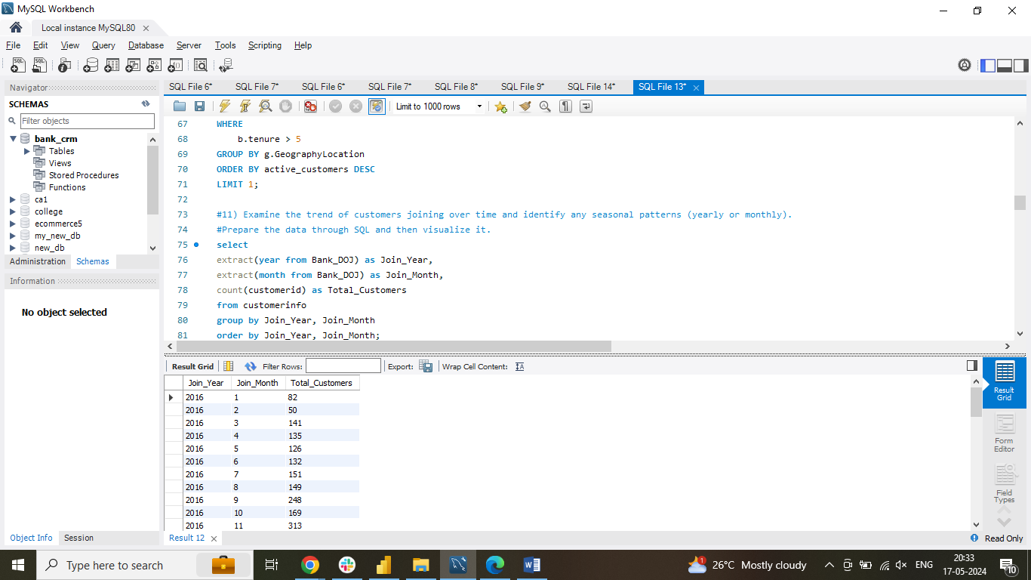

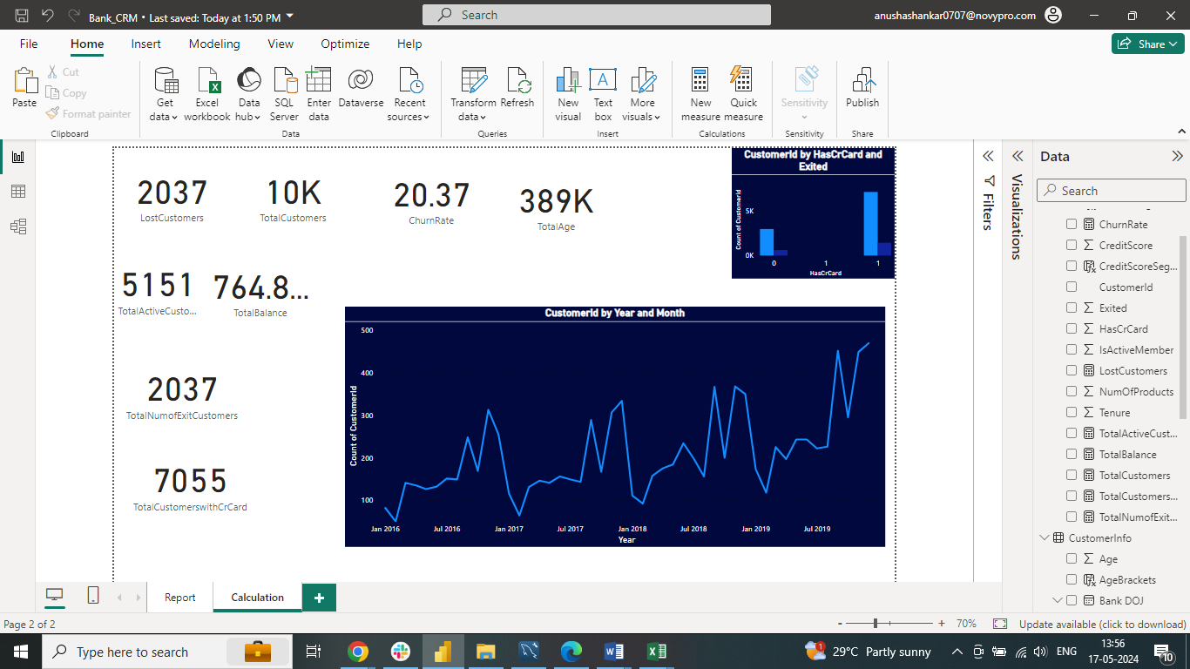

1. Analyze the relationship between the number of products and the account balance for customers who have exited

Based on the description provided, the bar chart illustrates the distribution of the number of products utilized by customers who have exited the bank (churned). The horizontal x-axis denotes the number of products used, while the vertical y-axis indicates the count of customers associated with each product count

Key Insights:

* The most prevalent usage scenario among exiting customers is with a single product. This implies that a substantial proportion of churned customers were engaged with only one product
* Moreover, there appears to be a declining trend as the number of products used increases. This suggests that customers who churned tended to have fewer products compared to active customers, indicating a potential correlation between lower product engagement and churn behaviour

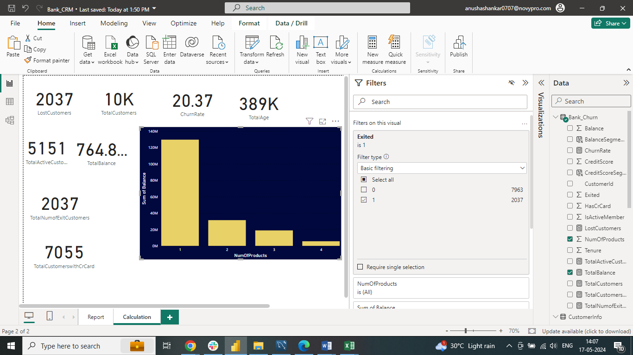

1. Identify any potential outliers in terms of balance among customers who have remained with the bank

Identifying potential outliers in terms of account balance among active customers involves several steps:

* Mean Balance Calculation: We computed the average balance (mean) of active customers
* Standard Deviation: The standard deviation of the balance was calculated to gauge the dispersion of data from the mean
* Outlier Threshold: Using the standard deviation, we estimated the range of the second standard deviation, typically used to identify outliers. This range, assuming a normal distribution, encompasses 95% of the data. In this case, the second standard deviation range was (-48302.68, 201274.46)
* Outlier Identification: Any balance amounts falling outside this second standard deviation range (greater than 201274.46 or less than -48302.68) were flagged as potential outliers

Detecting Outliers for Active Customers:

* A column chart likely illustrates the distribution of account balances for active customers
* Since there are no negative values and the minimum balance is zero, our focus is on identifying outliers on the higher end (above the upper threshold of 201274.46)
* We identified a total of 15 potential outliers

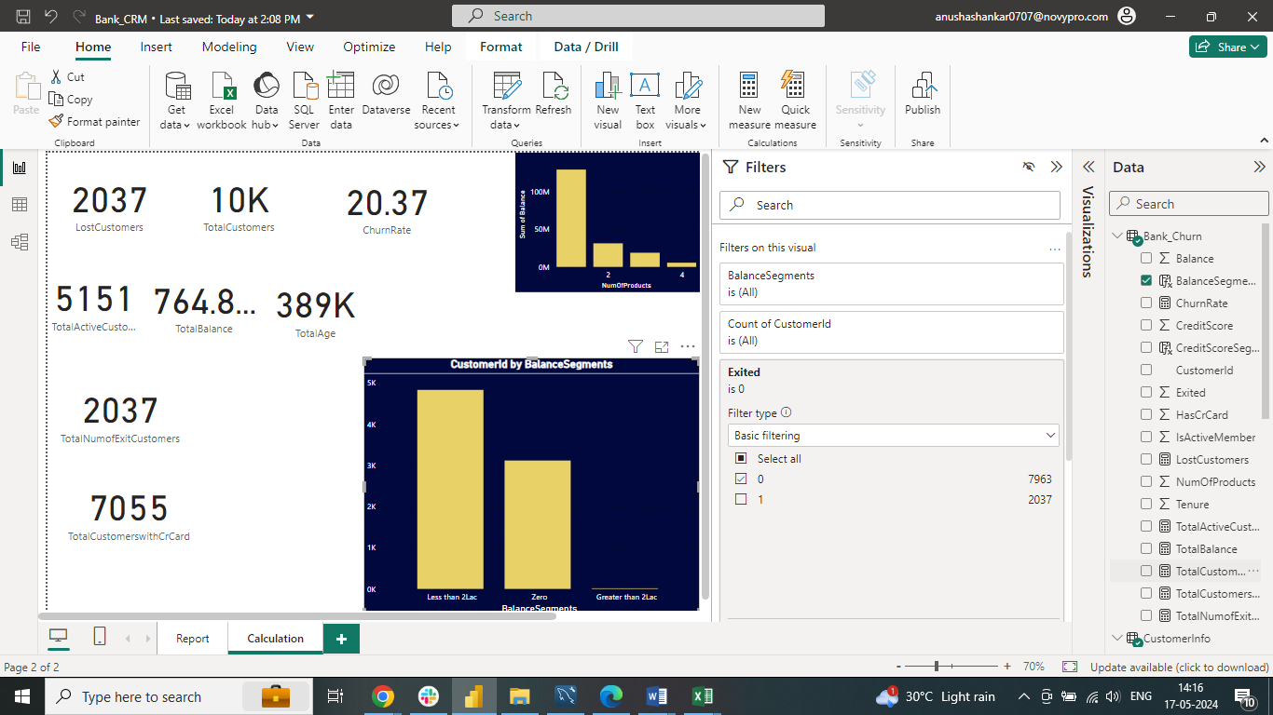

1. How many different tables are given in the dataset, out of these tables which table only consists of categorical variables?

Among our seven tables, each table contains categorical variables that play a significant role in understanding our data:

* In the CustomerInfo table, categorical variables such as Surname provide additional information about customers
* The ExitCustomer table includes categorical variables like Exit Category (Exit, Retain), which indicate whether customers have left the bank or remained
* Gender table holds categorical variables like Gender Category (Male, Female), which provide insights into the gender distribution of customers
* Geography table contains categorical variables like Geography Location (France, Spain, Germany), offering geographic information about customers
* ActiveCustomer table's categorical variable, Active Category (Active Member, Inactive Member), categorizes customers based on their activity status
* CreditCard table's categorical variable, Category (Credit-card holder, Non-Credit card holder), identifies customers who possess a credit card and those who don't

1. Using SQL, write a query to find out the gender-wise average income of males and females in each geography id. Also, rank the gender according to the average value (SQL)

This SQL code computes the average income (estimated salary) for males and females within each geographic location and assigns a rank based on the average salary

Common Table Expression (CTE) - geographic_avg_salary:

* Defines a CTE named geographic_avg_salary
* Joins the customerinfo (c) and geography (g) tables on GeographyID
* Utilizes a CASE statement to categorize genderid (assuming numeric) into 'Male' or 'Female' for clarity
* Groups the data by geographylocation and GenderID
* Calculates the average estimated salary (avg_salary) within each group using AVG(c.estimatedsalary)

Main Query:

* Selects all columns (*) from the geographic_avg_salary CTE
* Introduces a new column named rank using the RANK window function
* RANK assigns a rank (1 being the highest) within each geographylocation partition, ordering by avg_salary in descending order (highest average salary first)

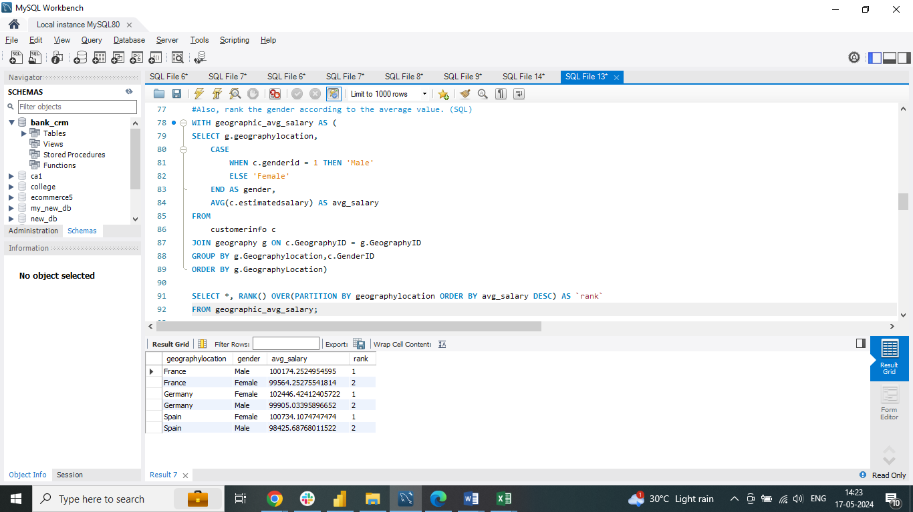

1. Using SQL, write a query to find out the average tenure of the people who have exited in each age bracket (18-30, 30-50, 50+)

This SQL query computes the average tenure (duration of time with the bank) of customers who have exited (Exited = 1), segmented into age brackets (18-30, 31-50, 50+), aiming to analyze churn patterns across various age groups

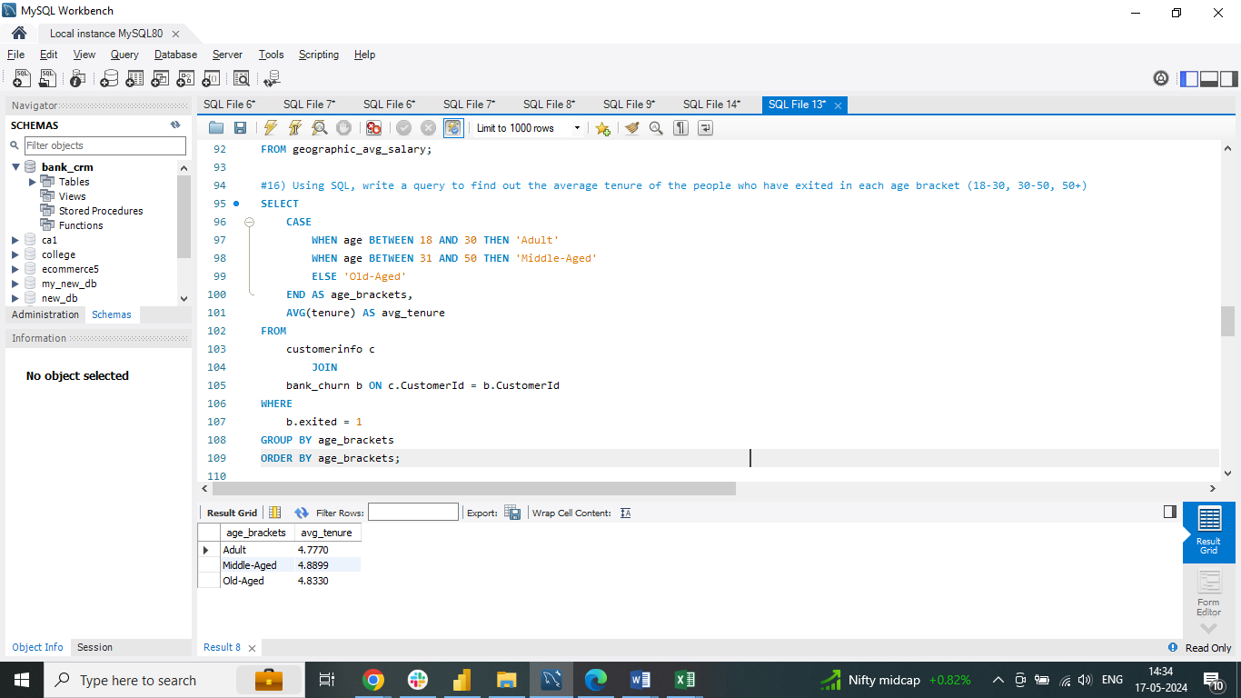

1. Is there any direct correlation between salary and the balance of the customers? And is it different for people who have exited or not?

Upon analysis, no direct correlation was observed between salary and account balance among customers. Additionally, this lack of correlation appears consistent regardless of whether customers have exited or not

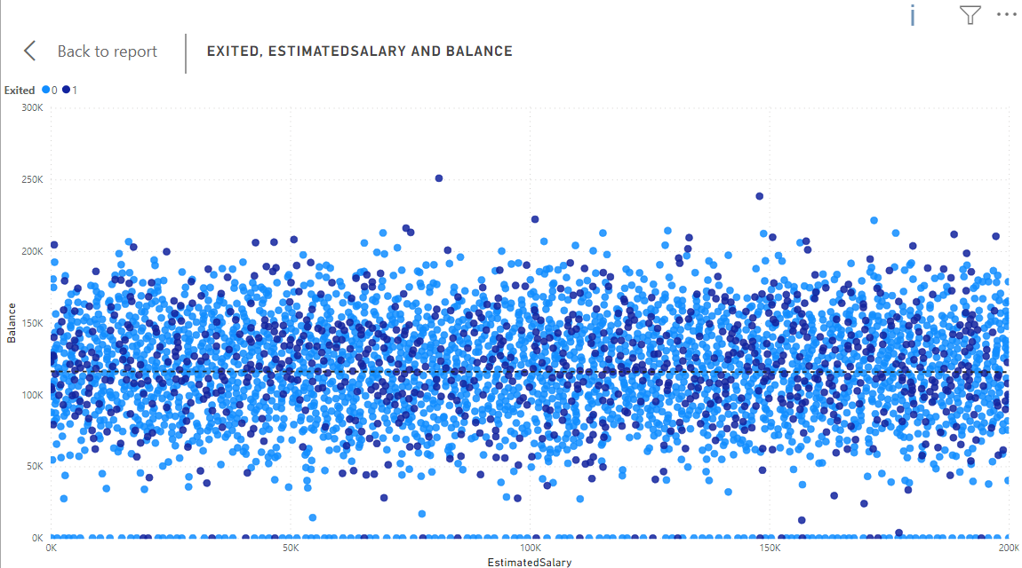

1. Is there any correlation between the salary and the Credit score of customers?

There isn't a discernible correlation between salary and credit score among customers. Credit score isn't solely determined by salary; it's influenced by a range of factors beyond income

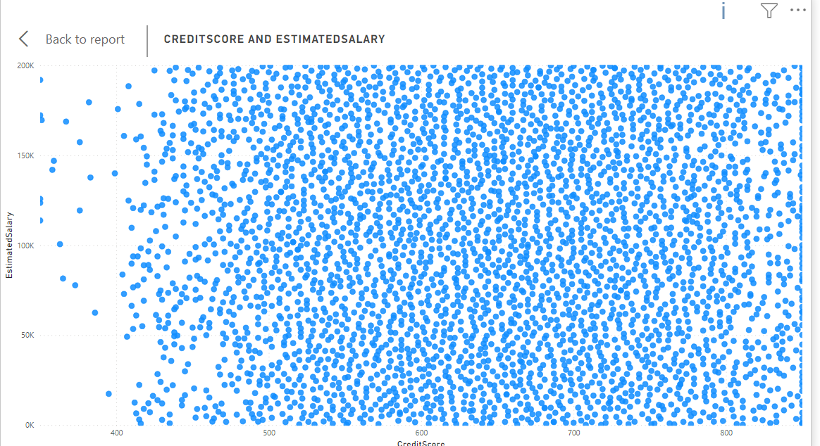

1. Rank each bucket of credit score as per the number of customers who have churned the bank

According to the chart, it illustrates the distribution of churned customers (count on the y-axis) across various credit score segments (x-axis). Here are the key insights:

Key Observations:

Churn Rate Variation by Credit Score: The chart demonstrates the churn rate, indicating the percentage of customers who exited, for each credit score segment. Notably, the segment with the tallest bar, specifically the Fair category, likely signifies the credit score group with the highest number of churned customers

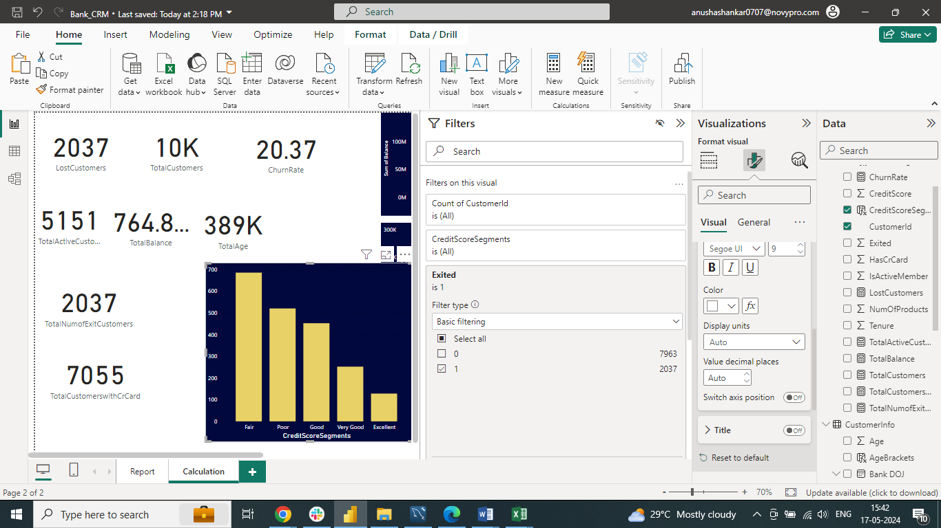

1. According to the age buckets find the number of customers who have a credit card. Also retrieve those buckets that have lesser than average number of credit cards per bucket

This SQL code examines the correlation between customer age groups ("age_brackets") and credit card ownership

Common Table Expression (CTE) - info:

* Establishes a CTE named info
* Joins the customerinfo (c) and bank_churn (b) tables on CustomerID
* Utilizes a CASE statement to categorize Age into 'Adult' (18-30), 'Middle-Aged' (31-50), and 'Old-Aged' (above 50)
* Filters for customers with credit cards (HasCrCard = 1)

Groups the data by age_brackets and calculates:

* HasCreditCard: The count of customers with credit cards within each age bracket

Main Query:

* Selects all columns (*) from the info CTE
* Subsequently, filters the results to include only age brackets where the count of customers with credit cards (HasCreditCard) is below the average number of credit cards per bracket
* The average is computed using a subquery that calculates the AVG(HasCreditCard) from the info CTE
* This query aids in identifying age groups with a credit card ownership rate below the average. By scrutinizing these segments, valuable insights into customer behavior can be gleaned, potentially facilitating the development of targeted marketing campaigns to bolster credit card adoption within these age groups

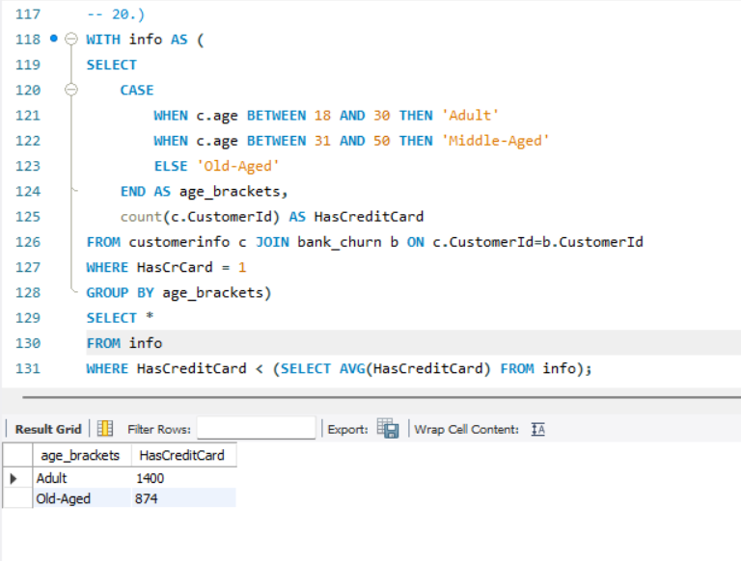

1. Rank the Locations as per the number of people who have churned the bank and average balance of the customers

This code extracts information to pinpoint locations with the highest number of churned customers (those who exited the bank)

Data Retrieval:

* It pulls data from three tables: bank_churn (providing customer churn information), customerinfo (containing customer details), and geography (offering location data)
* These tables are linked using customer IDs and location IDs

Filtering:

* The code focuses solely on customers who have churned (exited the bank)

Grouping and Ranking:

* It groups the data by location and determines the count of churned customers for each location
* Attempts to calculate an average balance per location (with a possibility of error in the exact calculation)

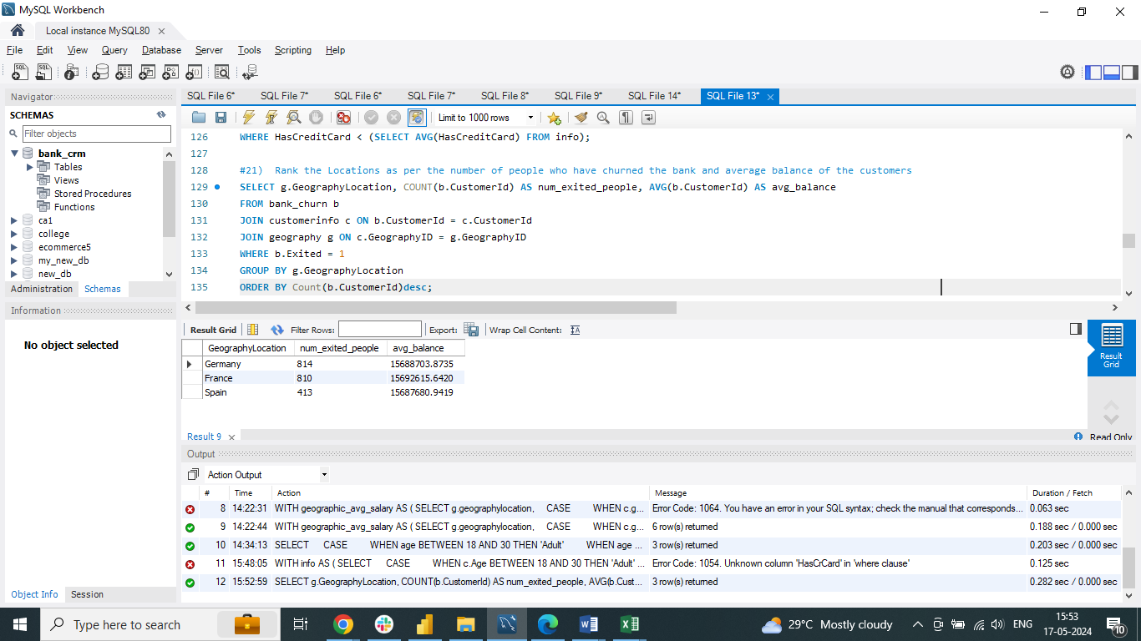

1. As we can see that the “CustomerInfo” table has the CustomerID and Surname, now if we have to join it with a table where the primary key is also a combination of CustomerID and Surname, come up with a column where the format is “CustomerID_Surname”

To create a new column named "CustomerID_Surname" in the result set of a join between the "CustomerInfo" table and another table with a composite primary key of CustomerID and Surname, follow these steps:

Data Types:

Ensure that the CustomerID column in the "CustomerInfo" table is of a character data type or can be converted to one. Depending on the database system, the CONVERT function may or may not be necessary

Join on Individual Columns:

Perform the join operation between the "CustomerInfo" table and the other table using separate columns for CustomerID and Surname, instead of relying on a combined primary key

Create New Column:

In the SELECT clause of your query, utilize a string concatenation function like CONCAT (or an equivalent function depending on the database system) to combine the CustomerID and Surname columns from the "CustomerInfo" table, separated by a delimiter (such as underscore "_")

1. Without using “Join”, can we get the “ExitCategory” from ExitCustomers table to Bank_Churn table? If yes do this using SQL

This code extracts customer data from the Bank_Churn table and introduces a new column named "ExitCategory" to categorize customers as either 'Retain' (indicating they have not churned) or 'Exit' (signifying churned customers), based on the values stored in the Exited column (presumably 0 for non-churned and non-zero for churned customers). It accomplishes this without relying on a JOIN operation, simplifying the process for single-table queries

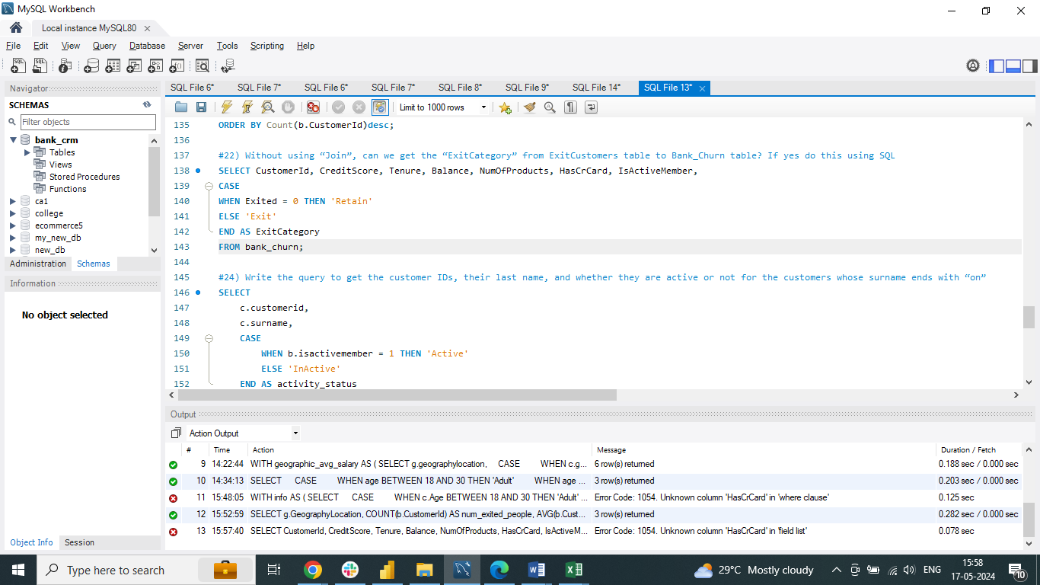 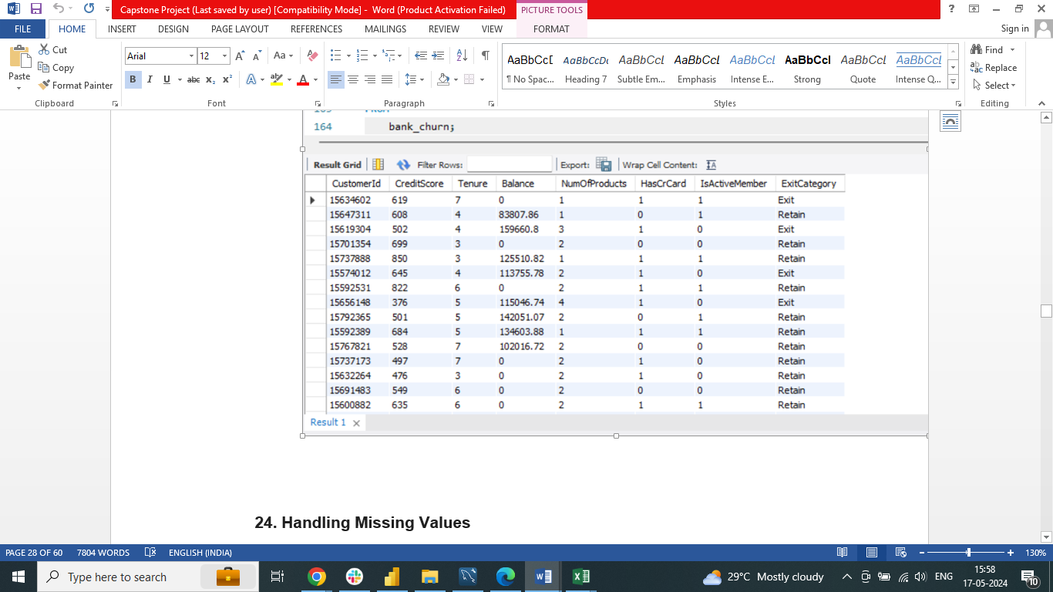

1. Were there any missing values in the data, using which tool did you replace them and what are the ways to handle them?

This segment addresses the issue of missing values, which arise when certain data points are either not recorded or unavailable. Fortunately, our dataset is devoid of missing values, obviating the necessity for employing imputation techniques that may introduce assumptions or biases.

General Strategies for Handling Missing Values are explained

While our current dataset is devoid of missing values, it's beneficial to be cognizant of common approaches for managing them in future analyses:

* Deletion: This entails removing rows or columns containing missing values. It may be suitable if the missing data is negligible and has minimal impact on the analysis, although it can result in information loss
* Imputation: This involves substituting missing values with estimated values. Methods encompass mean/median/mode imputation, k-Nearest Neighbors (KNN), or more advanced techniques. The choice of method should be guided by the data type and distribution
* Modeling Techniques: Certain statistical models can directly handle missing values. Nonetheless, comprehending the underlying reasons for missingness remains crucial

1. Write the query to get the customer IDs, their last name, and whether they are active or not for the customers whose surname ends with “on”

This SQL query extracts customer data for individuals whose surnames end with "on" in a case-sensitive manner. The retrieved information includes:

Customer ID: A unique identifier for each customer (obtained from the customerinfo table)

Last Name: The surname of each customer (derived from the customerinfo table)

Activity Status: This field indicates whether the customer is currently active ('Active') or inactive ('Inactive') with the bank, based on the isactivemember flag in the bank_churn table

By incorporating a regular expression (REGEXP ' on$') within the WHERE clause, the query precisely identifies surnames ending with the characters "on," preceded by a space

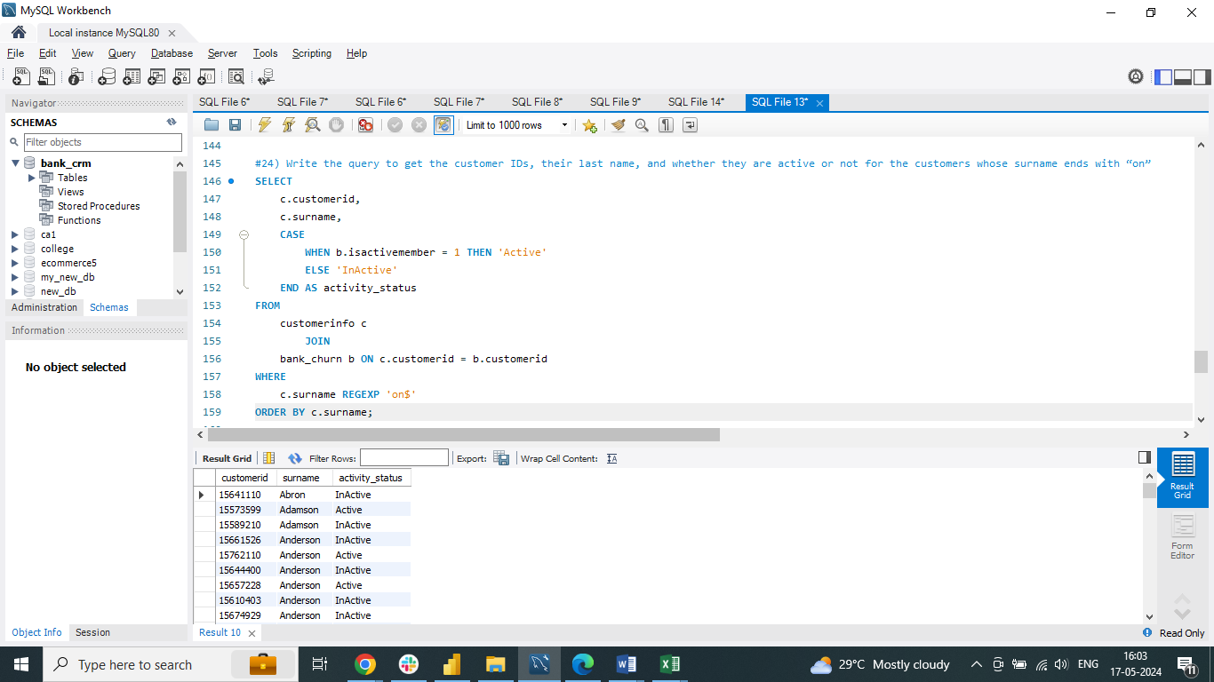

1. Can you observe any data discrepancy in the Customer’s data? As a hint it’s present in the IsActiveMember and Exited columns. One more point to consider is that the data in the Exited Column is absolutely correct and accurate

A noticeable discrepancy in the customer data is apparent when we observe that a considerable number, 735 to be precise, of customers who have already exited the bank are still being marked as active members. However, this inconsistency should not exist

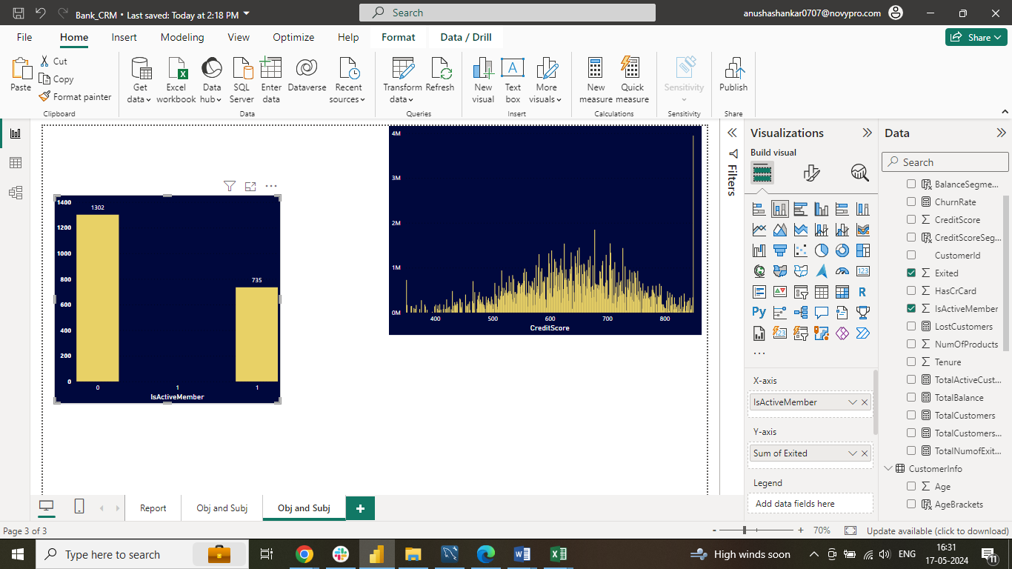

**Subjective Question:**

1. Customer Behavior Analysis: What patterns can be observed in the spending habits of long-term customers compared to new customers, and what might these patterns suggest about customer loyalty?

The graph indicates that long-term customers tend to have higher average balances compared to new customers. New customers show fluctuating average balances throughout the year, while long-term customers generally exhibit a rising trend in their average balance over time. This suggests that as customers stay longer with the bank, they tend to spend more. Possible reasons for this could include increased familiarity with the bank's offerings, income growth, or better incentives for long-term customers. Analyzing these spending patterns can aid the bank in crafting targeted marketing strategies for customer acquisition and retention

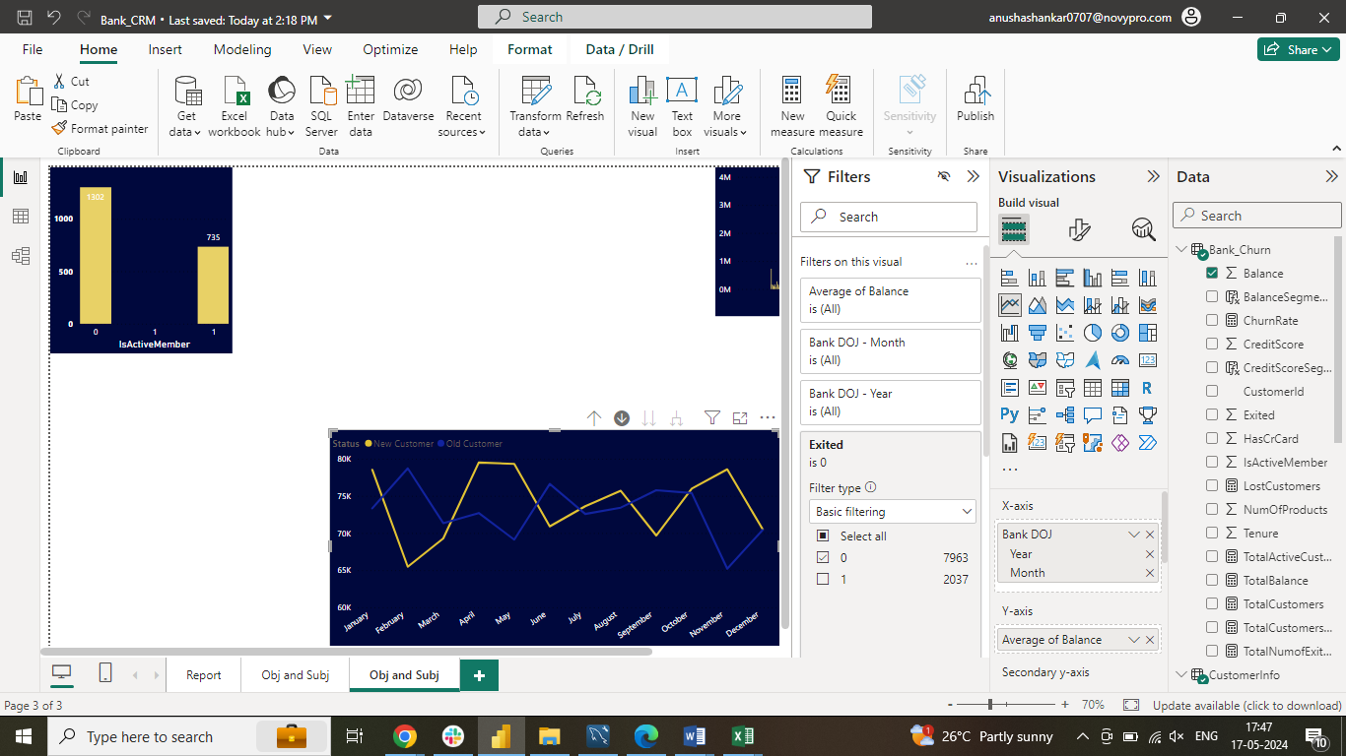

1. Product Affinity Study: Which bank products or services are most commonly used together, and how might this influence cross-selling strategies?

Commonly used bank products/services:

* Checking accounts
* Savings accounts
* Credit cards

Influence on cross-selling strategies:

* Offer tailored packages combining these services
* Promote packages with checking, savings, and credit card options
* Enhance customer loyalty and satisfaction
* Increase revenue through cross-selling opportunities

1. Geographic Market Trends: How do economic indicators in different geographic regions correlate with the number of active accounts and customer churn rates?

Average Balance by Geographic Location:

Germany has the highest average balance, which may indirectly relate to lower churn rates in regions with higher balances due to potentially lower cost sensitivity

Average Credit Score by Geographic Location:

Germany shows the highest average credit score, suggesting a possible link between higher credit scores and lower churn rates, as more creditworthy customers are less likely to switch

Average Salary by Geographic Location:

Variations in average salary across locations, with Germany having the highest, could also impact churn rates, potentially indicating that regions with higher salaries may experience lower churn rates

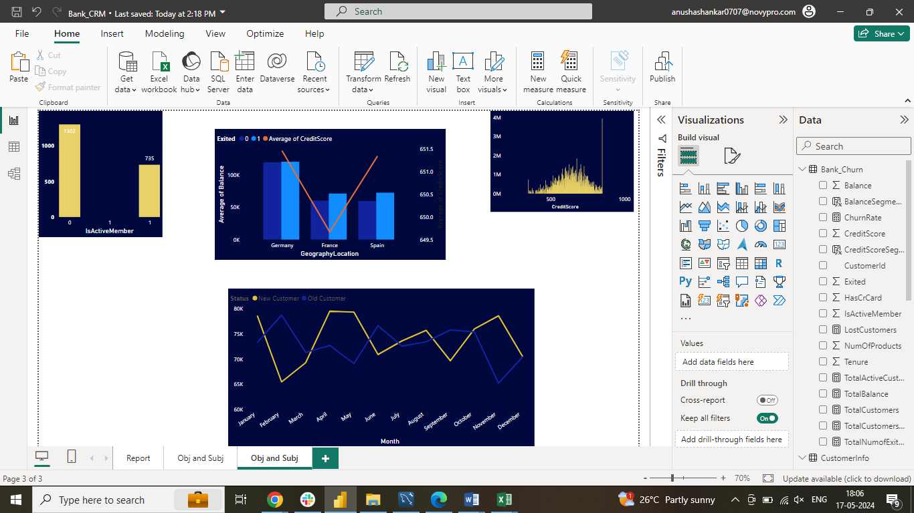

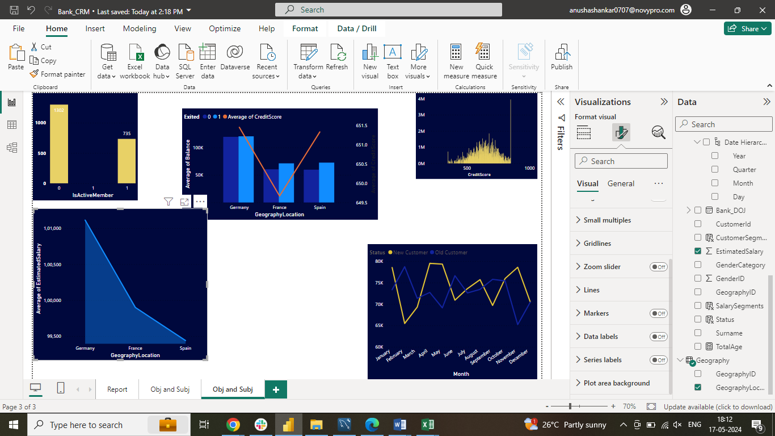

1. Risk Management Assessment: Based on customer profiles, which demographic segments appear to pose the highest financial risk to the bank, and why?

* The demographic segments with the most customers in the "Lower Middle Class" and "Poor" categories also represent the largest portion of the bank's customer base
* These segments with lower credit scores pose a higher potential financial risk to the bank due to the statistical likelihood of default on loans
* Creditworthiness is a significant indicator of a customer's loan repayment ability, with lower credit score customers being more prone to default
* Factors like income and employment history are also crucial in assessing customer risk, but creditworthiness strongly influences the likelihood of loan repayment and potential financial risk to the bank

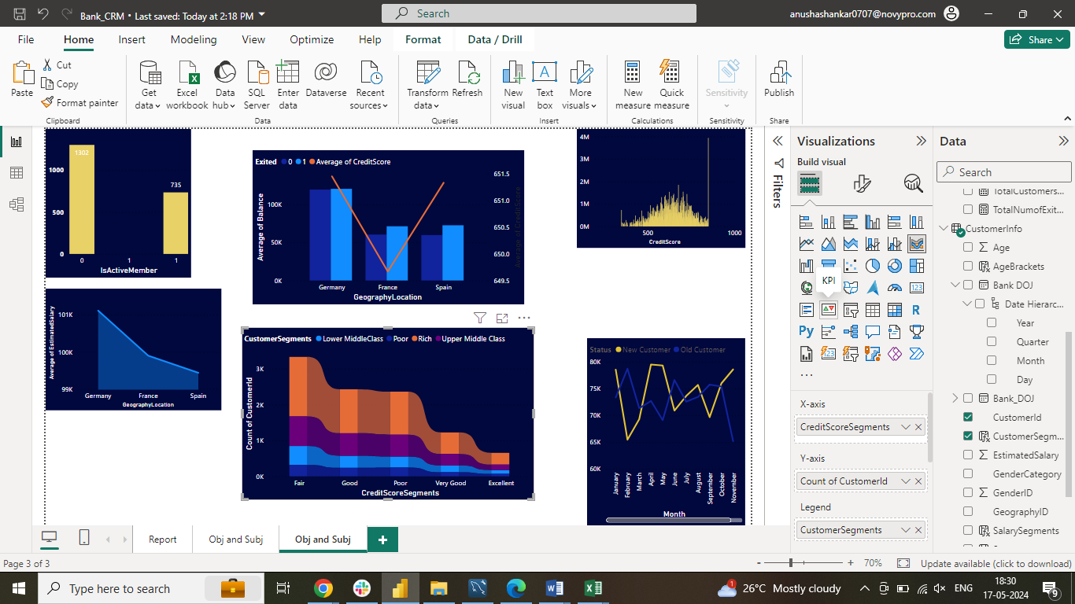

1. Customer Tenure Value Forecast: How would you use the available data to model and predict the lifetime (tenure) value in the bank of different customer segments?

* Customers with higher average balances tend to have longer tenures, likely due to greater investment in the bank's offerings or better retention incentives
* The segment with "High Salary & Greater than 2Lac" balance has the highest average tenure of around 5.4 years
* Customers with "Zero Balance" have the lowest average tenure across salary segments, around 4.2 years
* There is a weak correlation between salary segments and tenure, with slightly longer tenures for higher salary segments
* Predicted average tenures:
* High Salary: 4.8 - 5.4 years
* Low Salary & Lower Middle Class: 4.5 - 4.9 years
* Upper Middle Class & Rich: 4.8 - 4.9 years
* Balance segments are a more important factor in predicting tenure than salary segments
* Banks can target retention efforts towards higher balance segments and improve customer satisfaction across all segments

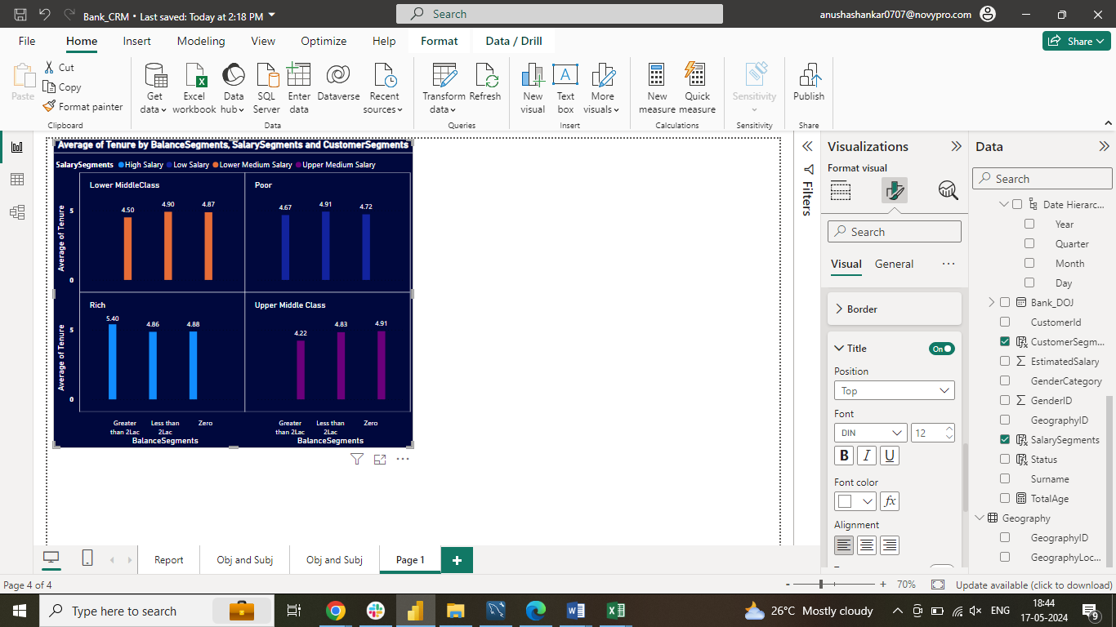

1. Marketing Campaign Effectiveness: How could you assess the impact of marketing campaigns on customer retention and acquisition within the dataset? What extra information would you need to solve this?

To assess the impact of marketing campaigns on customer retention and acquisition within a dataset, follow these steps:

* Define Metrics: Establish key metrics like customer churn rate for retention and new customer acquisition rate for acquisition
* Segment Data: Divide the data by different marketing campaigns to analyze each campaign's impact separately
* Calculate Metrics: Compute defined metrics for each segment and time period to track changes over time
* Compare Results: Contrast metrics across campaigns to identify the most effective ones for retention and acquisition
* Statistical Analysis: Use statistical tests to determine if differences in metrics between campaigns are statistically significant
* Additional Information: Consider customer demographics, campaign details, competitor data, and external factors to gain a comprehensive understanding of the impact of marketing campaigns on customer retention and acquisition within your dataset

1. Customer Exit Reasons Exploration: Can you identify common characteristics or trends among customers who have exited that could explain their reasons for leaving?

The bar chart indicates a potential correlation between credit card ownership and customer churn:

* Around 1,200 customers with credit cards exited the bank compared to around 300 without credit cards
* Further analysis is required to determine if the higher number of churned customers with credit cards is proportional to the total customer population

The chart does not provide information to evaluate the correlation between the number of products purchased and churn:

* Data on the number of products purchased by churned customers is needed to assess this potential relationship
* While credit card ownership may be associated with higher churn rates based on the chart, additional analysis is necessary to confirm this and consider factors like the total customer population's impact on the results
* The analysis of the number of products purchased in relation to churn cannot be conducted with the current information available

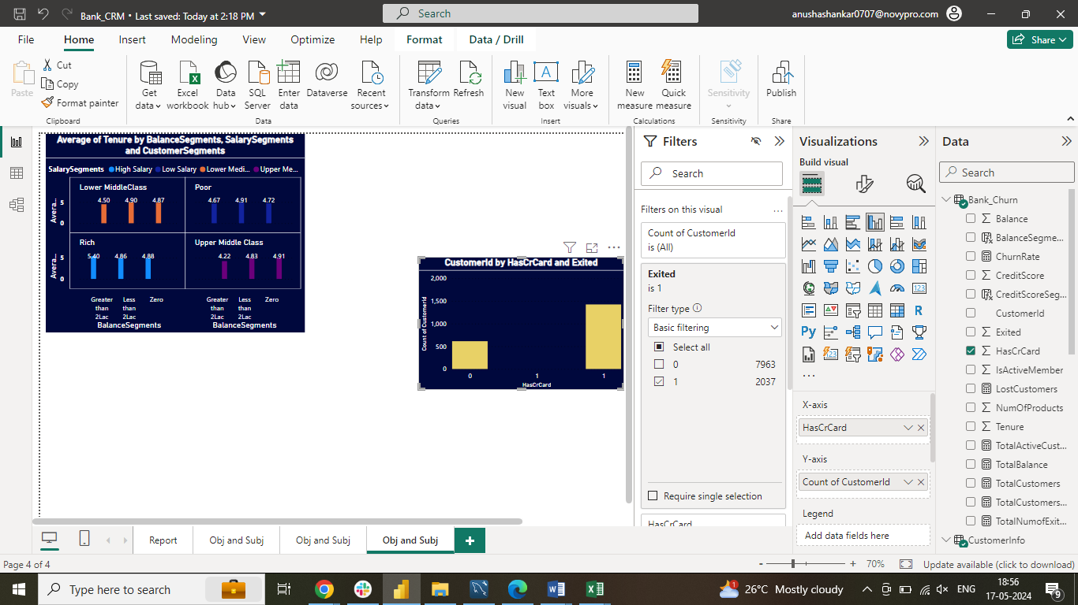

1. Are 'Tenure', 'NumOfProducts', 'IsActiveMember', and 'EstimatedSalary' important for predicting if a customer will leave the bank?

NumOfProducts: Inconclusive as a standalone predictor, but could be relevant with other attributes

Customers with more products may have needs met, reducing churn

Managing many products may frustrate some customers

Tenure: Suggests shorter tenures (0-24 months) are more predictive of churn

Active Member Status: Strength depends on distribution of churned customers across active/inactive

Estimated Salary: Lower salary segments show higher churn rates, indicating predictive value

Lower income customers may be more price-sensitive and less satisfied

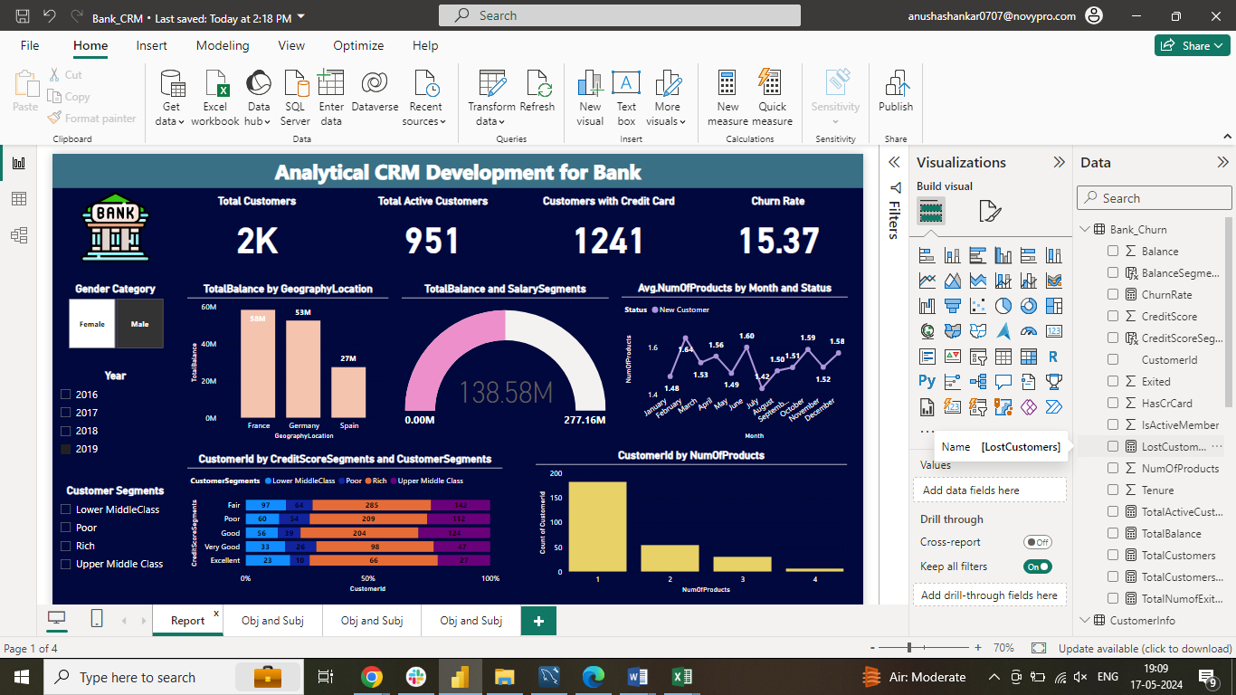 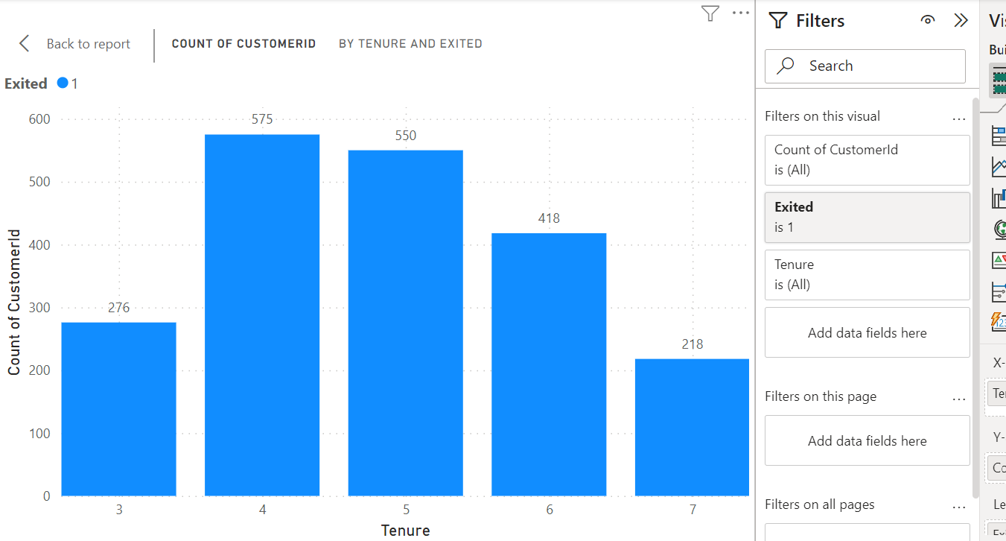

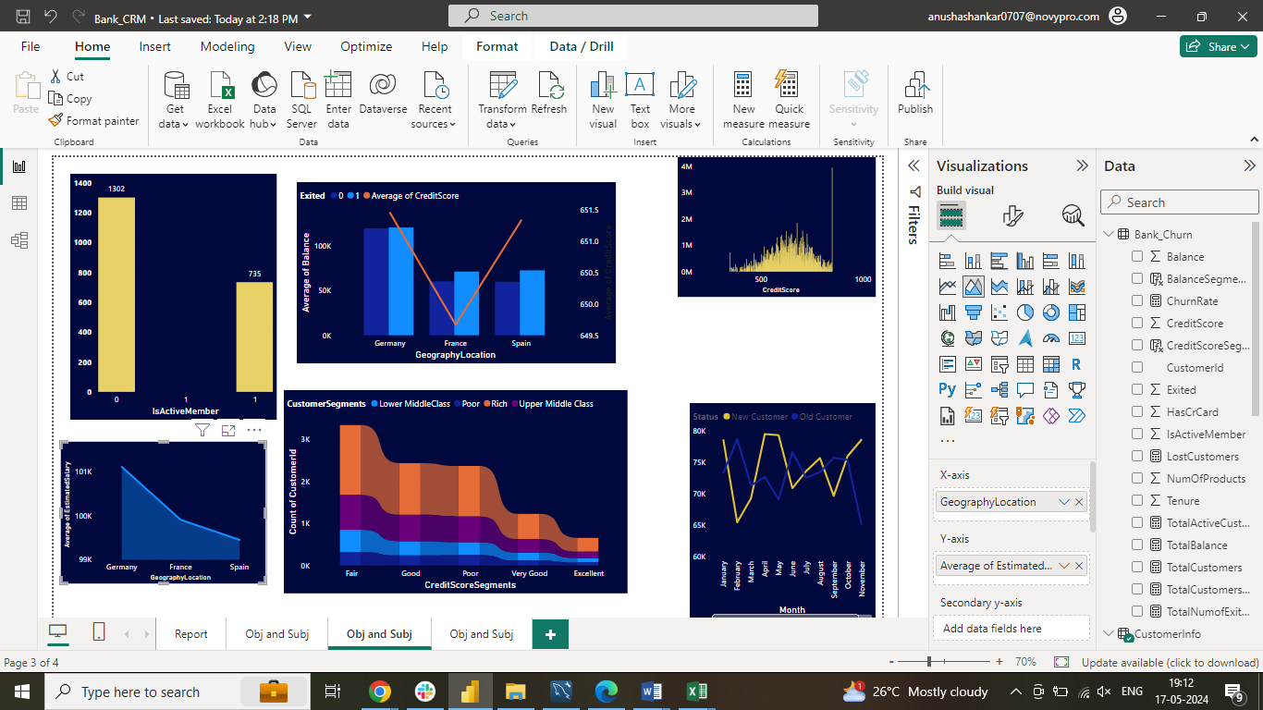 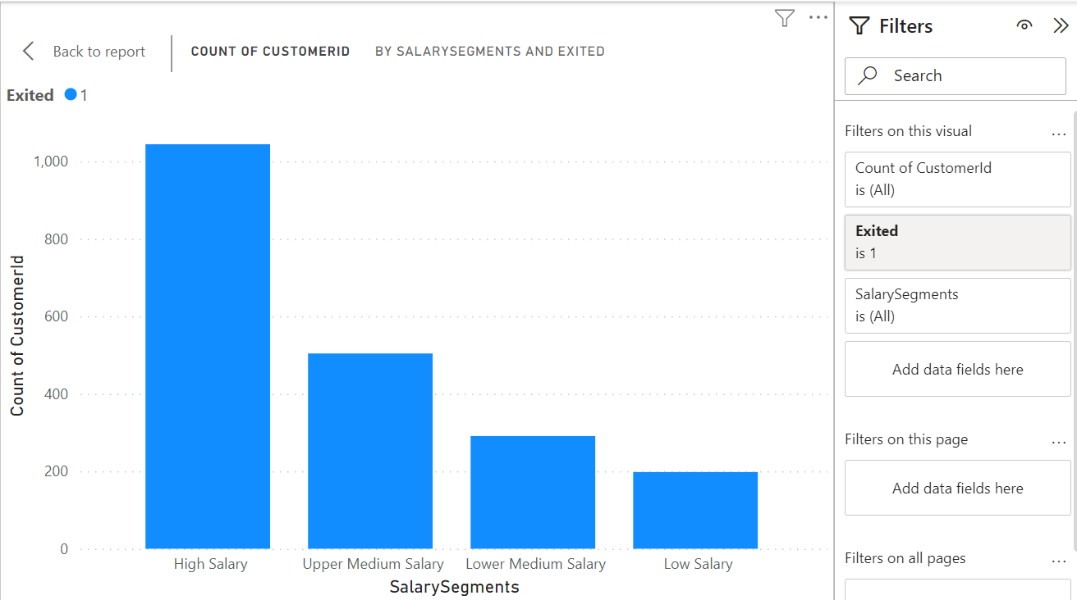

1. Utilize SQL queries to segment customers based on demographics and account details

* Customers are segmented based on income (Low, Medium, High), location (GeographyLocation), gender (Male/Female), and age
* The process involves joining customer data with geographic details, grouping by income, location, gender, and age
* Customer counts are calculated within each segment to analyze characteristics effectively
* Results are ordered by location and age to facilitate exploration of customer demographics and geographic regions

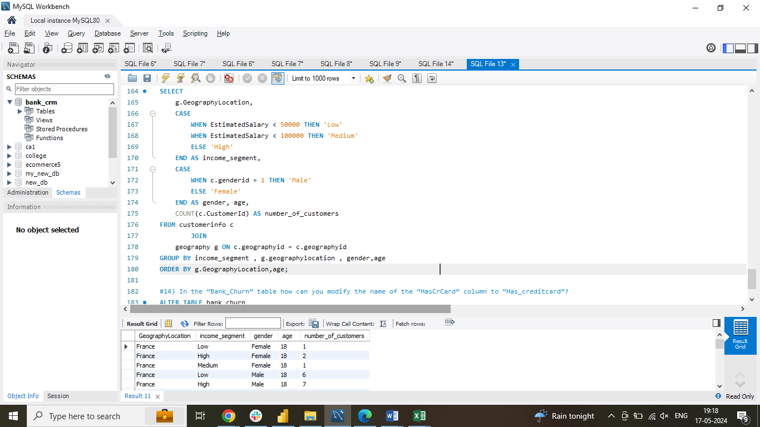

1. How can we create a conditional formatting setup to visually highlight customers at risk of churn and to evaluate the impact of credit card rewards on customer retention?

Define churn criteria based on factors like:

* Low number of products purchased (NumOfProducts)
* Low balance segments
* Recent exits (Exited) within a specified timeframe (e.g., last 6 months)
* Apply conditional formatting to highlight cells meeting the churn criteria using different colors or fonts for visual distinction
* Create a filter for the "HasCrCard" field to segment customers by credit card ownership (Yes/No)
* Analyze churn rates for customers with and without credit cards by comparing the number of exited customers (Exited = 1) to the total number of customers in each credit card ownership segment (HasCrCard = Yes or No)

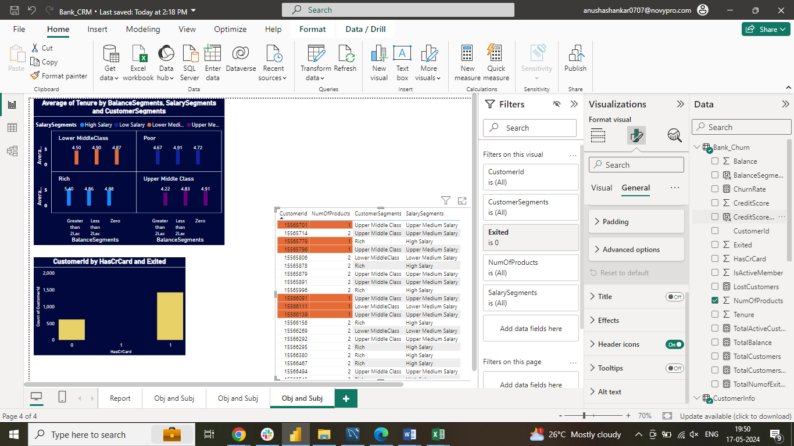

1. What is the current churn rate per year and overall as well in the bank? Can you suggest some insights to the bank about which kind of customers are more likely to churn and what different strategies can be used to decrease the churn rate?

Churn Rate Analysis:

* Overall churn rate: 20.37%

Year-on-year fluctuations:

* 2016: 19.27%
* 2017: 22.35% (highest)
* 2018: 20.21%
* 2019: 19.86% (lowest)

Customer Segments Prone to Churn:

* Customers with 1 product: Might seek more value elsewhere.
* Credit card holders: Reasons for churn include limited credit limits, lack of rewards, and high fees
* Tenure of 4-5 years: Susceptible to competitor offers
* High salary customers: More likely to switch for better benefits

Recommendations to Reduce Churn:

* Targeted Product Bundles: Offer tailored bundles to customers with one product
* Enhanced Credit Card Rewards: Improve rewards programs based on customer needs
* Retention Offers: Provide personalized deals to customers nearing introductory offer ends
* Customer Satisfaction Surveys: Gather feedback to enhance services and retention strategies
* Relationship Management: Assign dedicated managers for high-value customers for personalized service and benefits

1. Create a dashboard incorporating all the KPIs and visualization-related metrics. Use a slicer in order to assist in selection in the dashboard

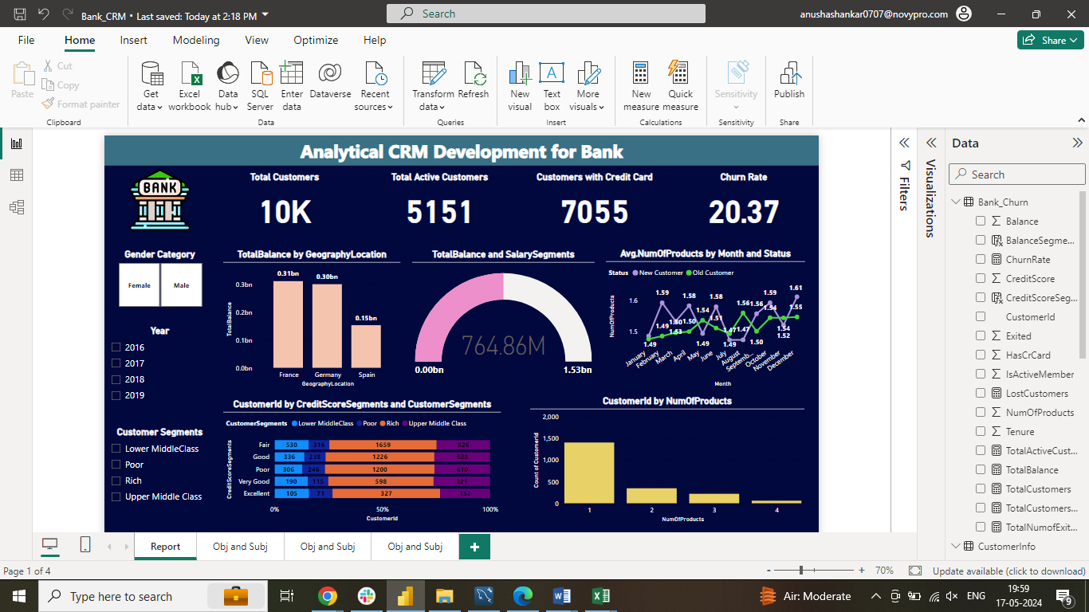

1. How would you approach this problem, if the objective and subjective questions weren't given?

Customer Attrition Analysis

* Explore demographic patterns in churn
* Investigate impact of account balance and product usage on churn
* Analyze relationship between customer activity and churn

Campaign Effectiveness Analysis

* Identify most effective channels for target audience reach
* Assess correlation between ad spend and campaign performance
* Evaluate messaging impact on customer engagement and conversions

Data Exploration

* Utilize data visualization and statistics to address formulated questions

Decision Making

* Derive actionable insights to inform decisions regarding customer behavior, marketing strategies, or product improvements

1. In the “Bank_Churn” table how can you modify the name of the “HasCrCard” column to “Has_creditcard”?

This code changes the name of the "HasCrCard" column to "Has_creditcard" in the "Bank_Churn" table. It improves clarity by using a more descriptive name

